We need to replicate what we did for the Print Customer Deposit button on the sales order form to create a ‘commercial invoice’ button.

We will want the button to be next to the Print Deposit button on the sales order form:

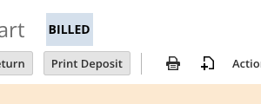

Here is what is needed:

* Custom PDF that will be in the same format as the Print Deposit PDF, but with the following changes:
  + The header should read as Commercial Invoice instead of Sales Order.

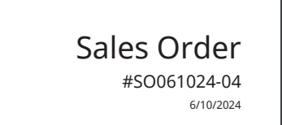

* There are two new fields on the sales order line:
  + Customs Rate (custcol_wdym_customs_rate): This will always default to a value of $1.00.
  + Customs Amount (custcol_wdym_customs_amount) : This will be a calculated field that will be qty x Customs Rate.
* The rate field on the PDF should work with the following logic:
  + If customer ID on the sales order = 6655 then populate the Rate field on the PDF with the value from field ID custcol_wdym_customs_rate else populate with the value from the Item Rate field.
* The Amount field for the line on the PDF should work with the following logic:
  + If customer ID on the sales order = 6655 then populate the line level Amount field on the PDF with the value from field ID custcol_wdym_customs_amount.
* There are additional fields that were added to the Print Deposit PDF, such as UPC and HTC code, so logic should work as follows:
  + If customer ID on the sales order != 6655 then display those fields on the PDF, else do not display those fields on the PDF.
* There is a new checkbox field created on the sales order with ID custbody_wdym_comm_inv_printed. When the Print Commercial Invoice button is clicked the system should generate a PDF commercial invoice for any sales order where the Ship To Country does NOT equal United States and custbody_wdym_comm_inv_printed is FALSE. Once the PDF has been generated, this field needs to be set to TRUE. We will want this to only look at orders created current day.
* The ‘footer’ of the commercial invoice should include the following:
  + Memo field is currently printing and should remain as is.
  + The following verbiage should print just below the Memo field at the footer: CUSTOMS VALUE ONLY 1 USD SAMPLE ONLY/NOT FOR RESALE.

For the PDF, remove the following:

* Remove the deposit notes and barcode from the bottom of the form.

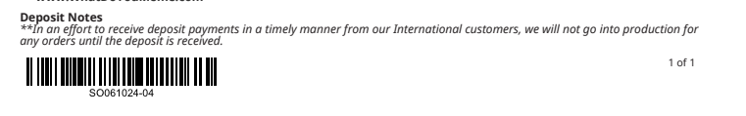

* Only have the ‘total’ field. Remove subtotal, tax total, customer deposit, required deposit due and payment applied.

